

Exclusive Investment Offering
OFFERING MEMORANDUM
Lchaim Farm
Assemblage
± 10-Acre Multifamily Redevelopment Opportunity
Woodland Lane • Dania Beach, Florida

Income-Producing Multifamily · Land Bank · Density Upside

PRESENTED BY
Michael Benmeleh
Licensed Real Estate Broker · Beach City Realty · Lic. #3123199
305-978-5988 showmemyami.com
CONFIDENTIAL — FOR THE INTENDED RECIPIENT ONLY

Confidentiality & Disclaimer

This Offering Memorandum (the “Memorandum”) has been prepared by Beach City Realty (the “Broker”) solely to assist prospective purchasers in evaluating a possible acquisition of the property described herein (the “Property”). It is provided on a confidential basis for the sole use of the recipient and may not be reproduced, distributed, or shared with any other party without the prior written consent of the Broker.
The information contained in this Memorandum has been obtained from sources believed to be reliable; however, the Broker and the owner of the Property (the “Owner”) make no representation or warranty, express or implied, as to the accuracy or completeness of the information. Square footage, acreage, unit counts, zoning, entitlement status, income figures, and all other data are estimates and are subject to verification.
All references to potential development, density, rezoning, unit counts, and permitted uses are illustrative only and are expressly subject to governmental and municipal approvals that have not been granted for the Property. Nothing herein should be construed as a guarantee that any such approval or development outcome will be achieved.
Prospective purchasers are urged to conduct their own independent investigation and to rely solely upon their own due diligence, advisors, and verification of all matters material to a purchase decision, including but not limited to title, survey, zoning, environmental condition, physical condition, and financial performance.
This Memorandum does not constitute an offer to sell or a solicitation of an offer to buy the Property. The Owner reserves the right, at its sole discretion, to reject any or all offers, to withdraw the Property from the market at any time, and to terminate discussions with any party at any time, with or without notice.

By accepting this Memorandum, the recipient agrees to be bound by the terms set forth above.

Table of Contents

01 Executive Summary
02 Property Overview
03 The Assemblage — Parcel Detail
04 Investment Highlights
05 Adjacent Redevelopment Precedent — Koosh Living
06 Location & Demand Drivers
07 Development Opportunity
08 Market Fundamentals
09 Financial Overview

01 Executive Summary

Beach City Realty is pleased to present the exclusive opportunity to acquire the Lchaim Farm Assemblage — a rare collection of income-producing multifamily properties and development parcels totaling approximately ±10 acres in the heart of Dania Beach, Florida.
The assemblage is comprised of multiple contiguous parcels currently improved with multifamily residences and supplemented by vacant land. This combination offers investors, developers, and land bankers an uncommon pairing of immediate, in-place income and substantial long-term redevelopment potential within one of Broward County’s fastest-growing corridors.
Strategically positioned directly adjacent to the approved Koosh Living mixed-use development, the Property benefits from a clearly demonstrated municipal precedent for significant density increases on formerly estate-zoned land in the immediate area — a precedent that frames the value-creation thesis for this offering.

±10  Acres | 9  Min to FLL Airport* | E-1  Current Zoning | 231  Adjacent Approved Units
*Drive times are approximate and provided for general reference.

02 Property Overview

Property Summary
Property Name | Lchaim Farm Assemblage
Location | Woodland Lane, Dania Beach, Florida
Site Size | Approximately ±10 acres
Configuration | Multiple contiguous parcels
Current Improvements | Existing multifamily residences
Income Profile | Income-producing units in place
Vacant Land | Included within the assemblage
Current Zoning | E-1 Estate Residential
Utilities | Existing utilities available to the site
County | Broward County, Florida

Position & Access
✓ Minutes to Fort Lauderdale–Hollywood International Airport
✓ Minutes to the Seminole Hard Rock Hotel & Casino
✓ Easy access to I-95, I-595, Florida’s Turnpike, and US-441
✓ Located within a high-growth Central Broward redevelopment corridor
✓ Directly adjacent to the approved Koosh Living mixed-use project

Note: Parcel-level detail — individual folio numbers, lot dimensions, unit-by-unit breakdown, and survey — is available to qualified parties upon execution of a confidentiality agreement.

03 The Assemblage — Parcel Detail

The assemblage is comprised of contiguous parcels of record along Woodland Lane. The aerials on the following pages show each parcel outlined in red, paired with current data from the Broward County Property Appraiser (BCPA). Together, the parcels pair two improved, income-capable holdings with a large, essentially vacant development tract.

Assemblage Snapshot
Parcel | Situs Address | Status
1 | 5511 Woodland Lane | Improved
2 | 5501 Woodland Lane | Improved
3 | SW 54 Street | Vacant land
Total | Three parcels of record

Parcel data and boundaries are sourced from the Broward County Property Appraiser and are provided for reference only. Parcel boundaries shown are approximate and do not constitute a survey. The assemblage may include additional parcels; full parcel-level detail is available upon execution of a confidentiality agreement.

Lot Breakdown
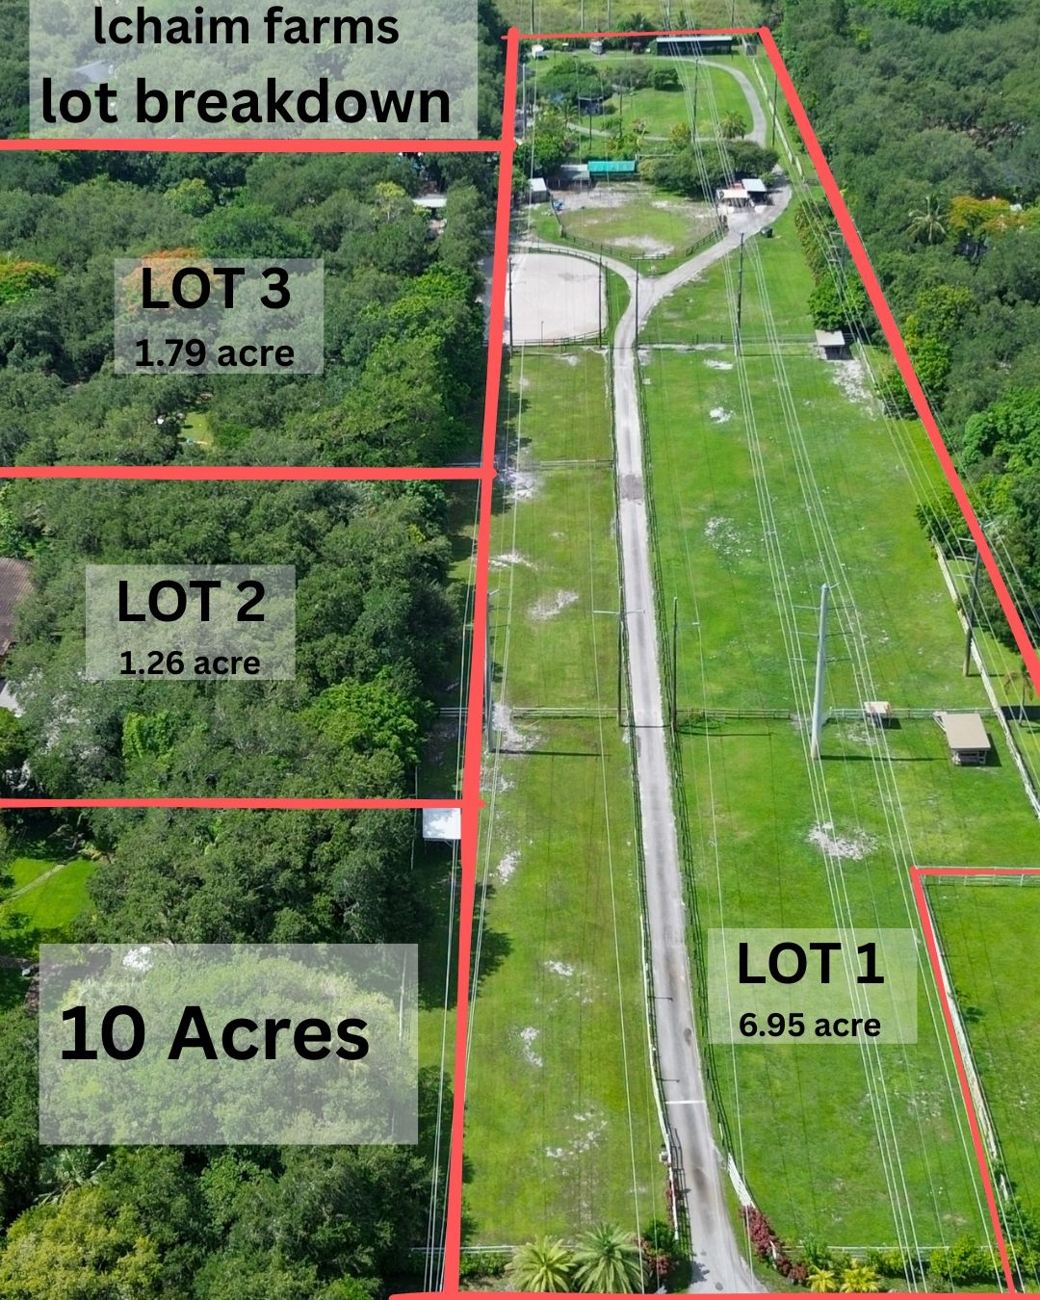
Illustrative lot breakdown of the L'Chaim Farms assemblage (boundaries approximate; not a survey).

Parcel 1 · 5511 Woodland Lane
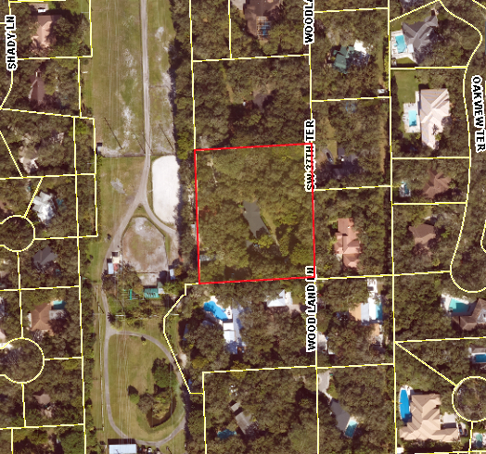
BCPA aerial — subject parcel outlined in red (boundaries approximate; not a survey).

Situs Address | 5511 Woodland Lane, Dania Beach, FL 33312
Folio / Parcel ID | 50-4231-01-0486
Owner of Record | L’Chaim Farm LLC
Use Code (BCPA) | 01
Improvements | Improved
Legal (abbrev.) | Reed Land Co Sub 2-32, Blk 3 — S 300 of N 925 of W½ of Tr 7 & S 300 of N 925 of Tr 8, less W 270 of Tr 8

Parcel 2 · 5501 Woodland Lane
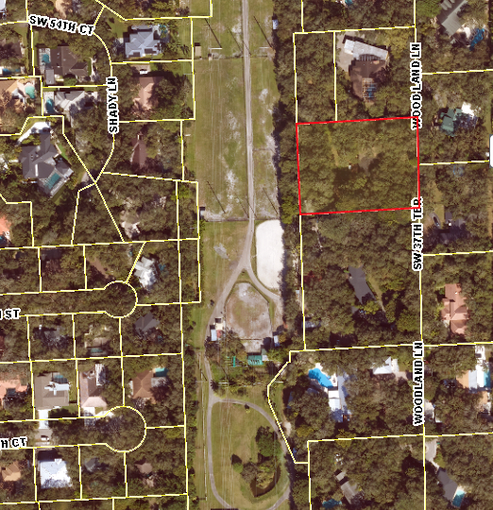
BCPA aerial — subject parcel outlined in red (boundaries approximate; not a survey).

Situs Address | 5501 Woodland Lane, Dania Beach, FL 33312
Folio / Parcel ID | Available upon request
Use Code (BCPA) | 63
Improvements | Improved
Last Recorded Sale | $1,500,000 — September 2021 (Warranty Deed)
Legal (abbrev.) | Reed Land Co Sub 2-32, Blk 3 — S 200 of N 625 of W½ of Tr 7 & S 200 of N 625 of Tr 8, less W 270 of Tr 8

Parcel 3 · SW 54 Street (Development Tract)
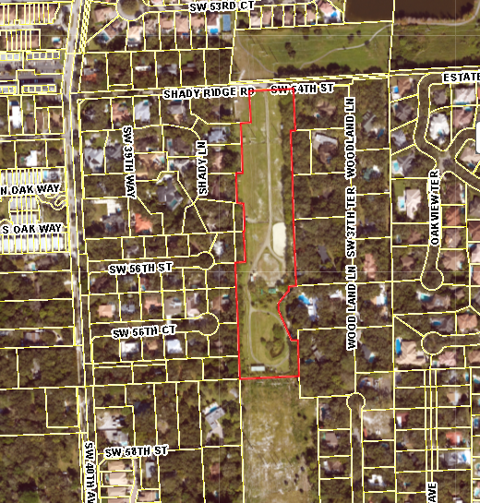
BCPA aerial — the large vacant development tract outlined in red (boundaries approximate; not a survey).

Situs Address | SW 54 Street, Dania Beach, FL 33312
Folio / Parcel ID | 50-4231-01-0487
Owner of Record | L’Chaim Farm LLC
Use Code (BCPA) | 00 — Vacant
Improvements | Vacant land
Legal (abbrev.) | Reed Land Co Sub 2-32, Blk 3 — a portion of Tr 8, more particularly described by metes and bounds

Property Photography

The subject property sits beneath a mature oak canopy and is currently improved with multiple residences, equestrian facilities, gardens, and event and gathering space. The following photographs illustrate the grounds and existing improvements. Additional imagery is available to qualified parties upon request.
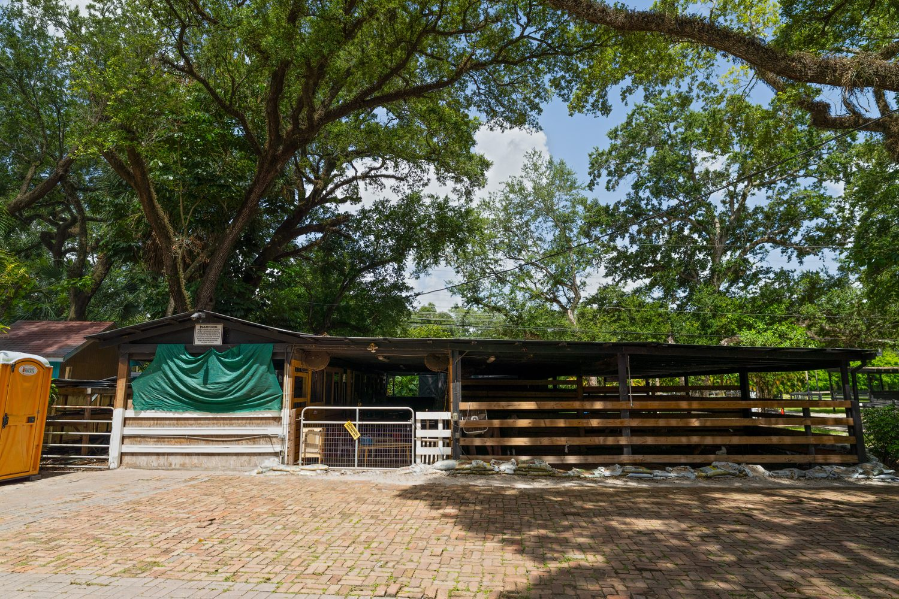
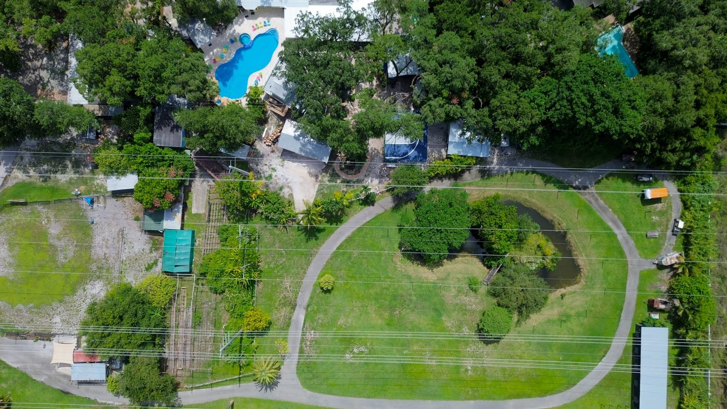
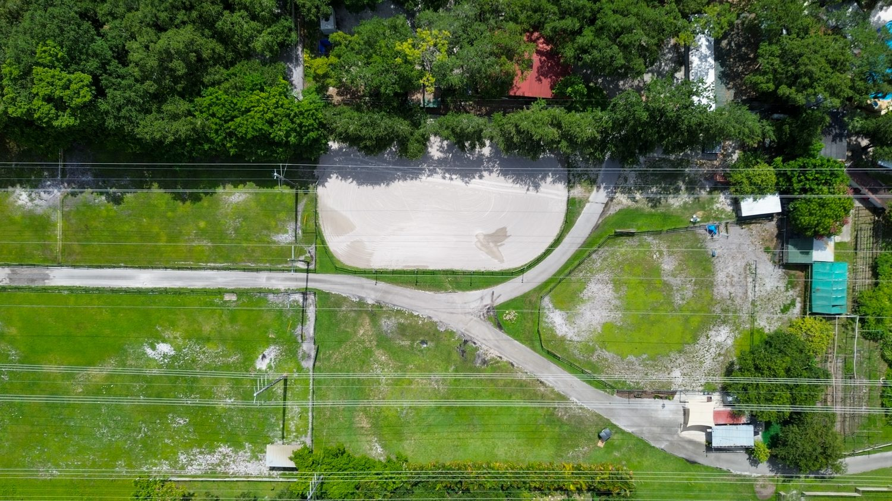
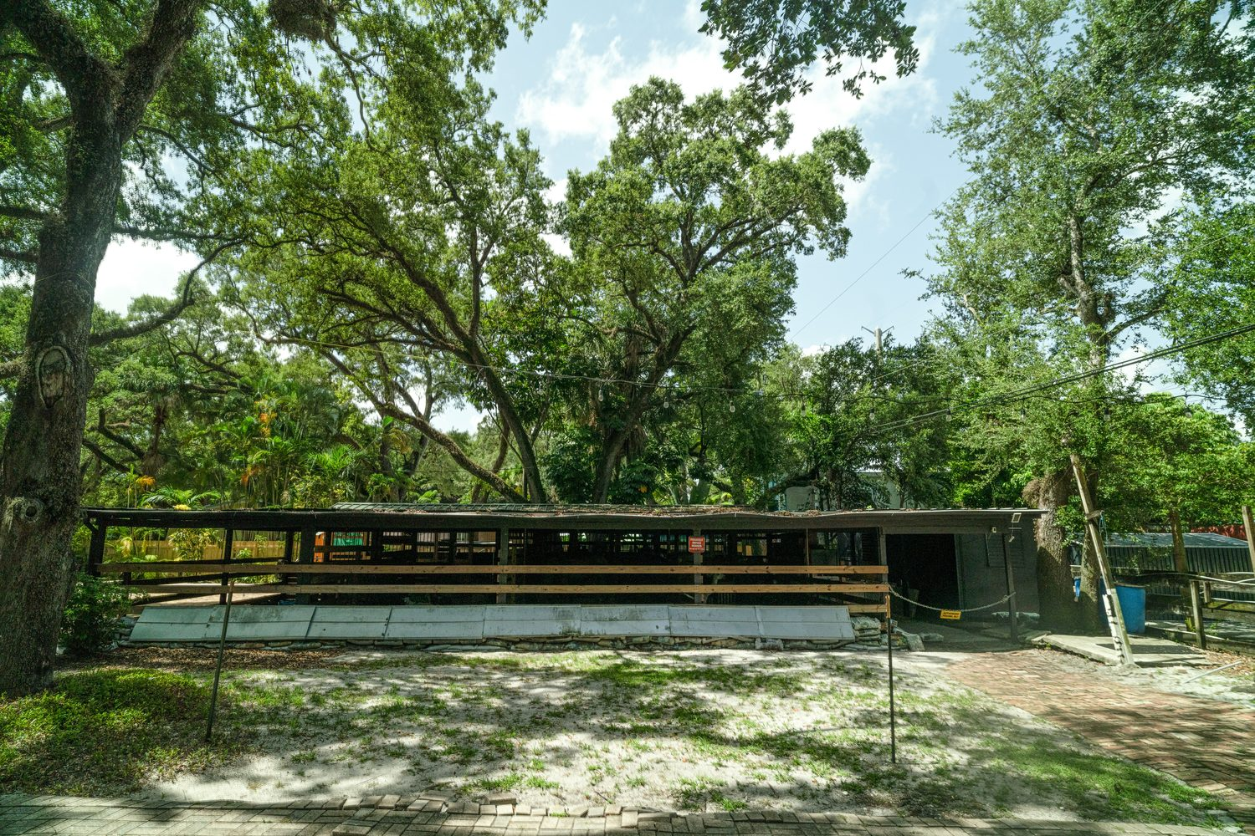
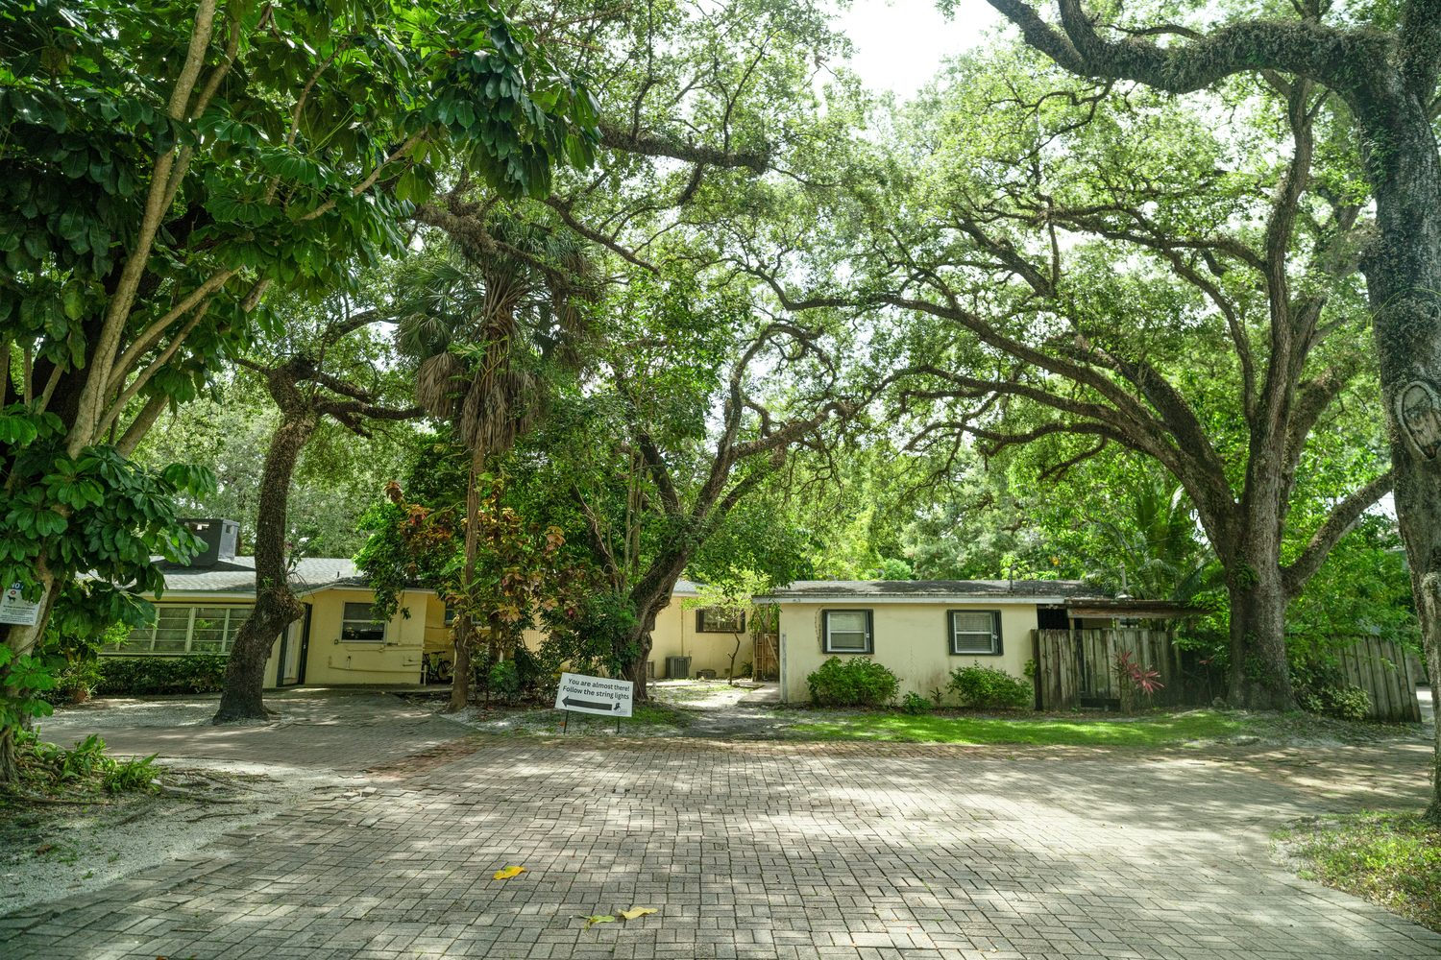
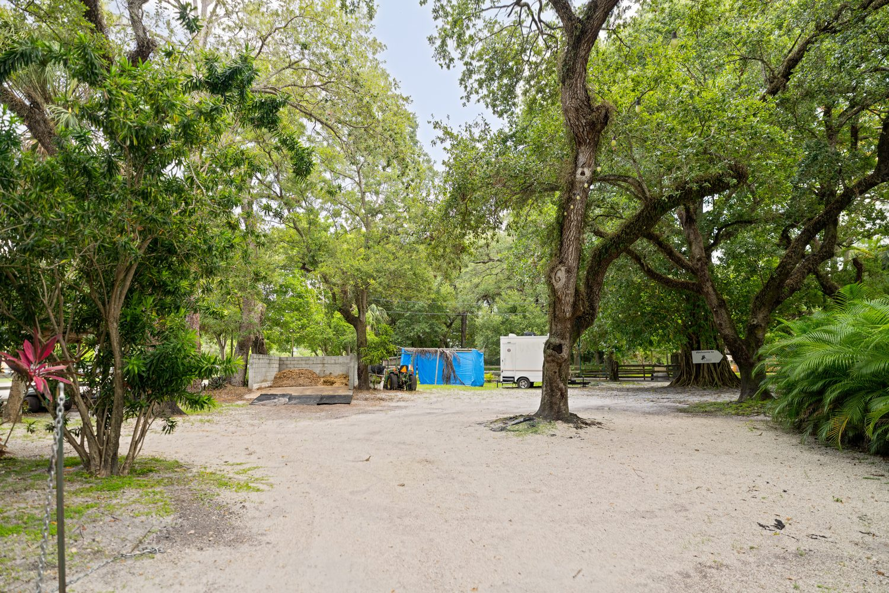
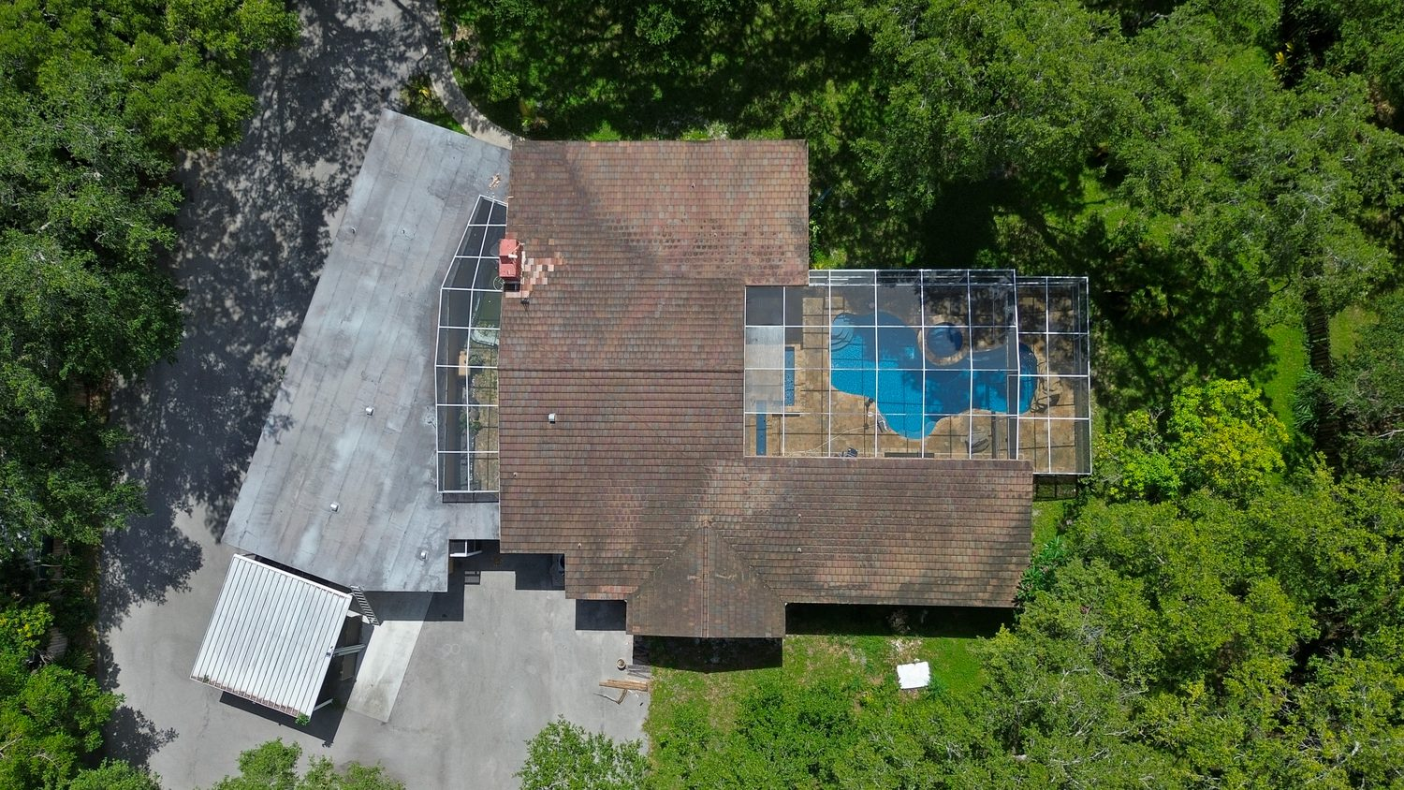
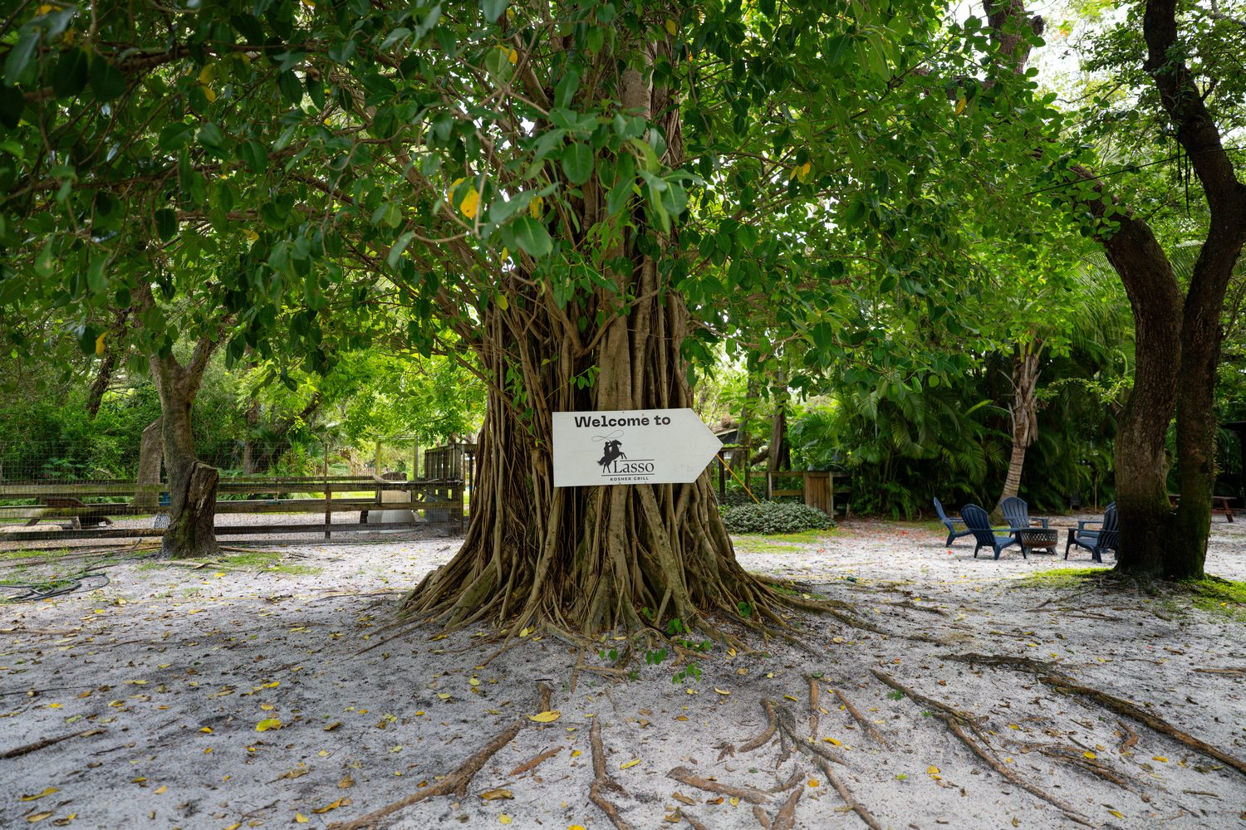
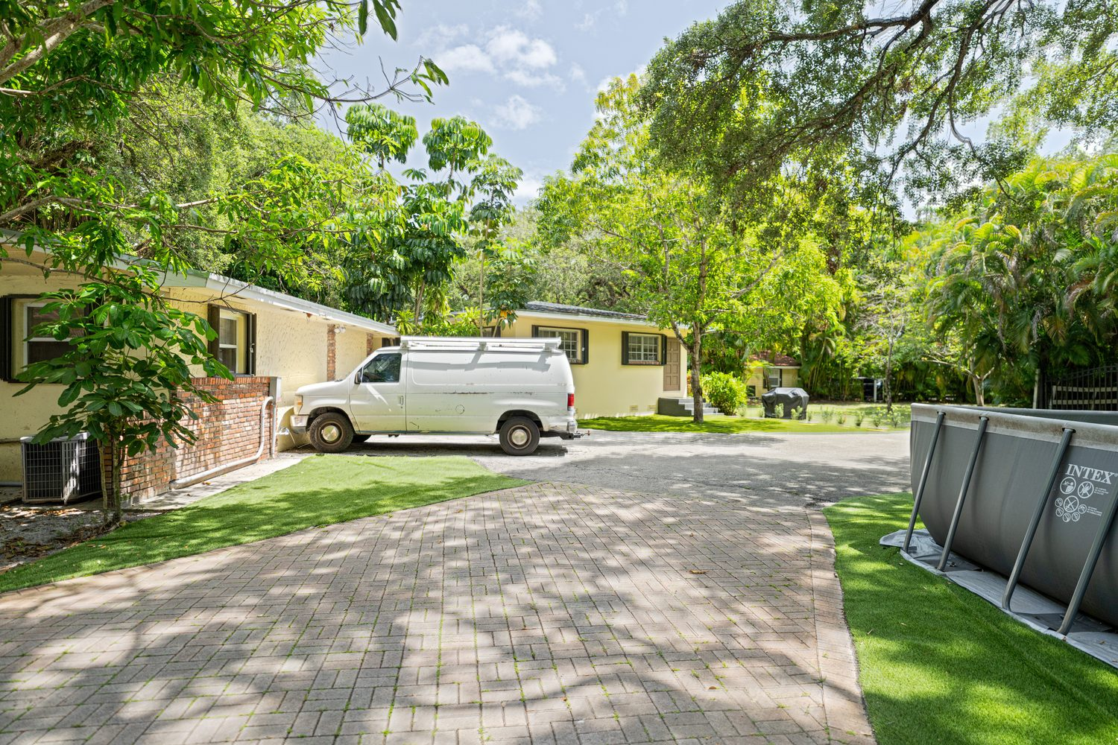
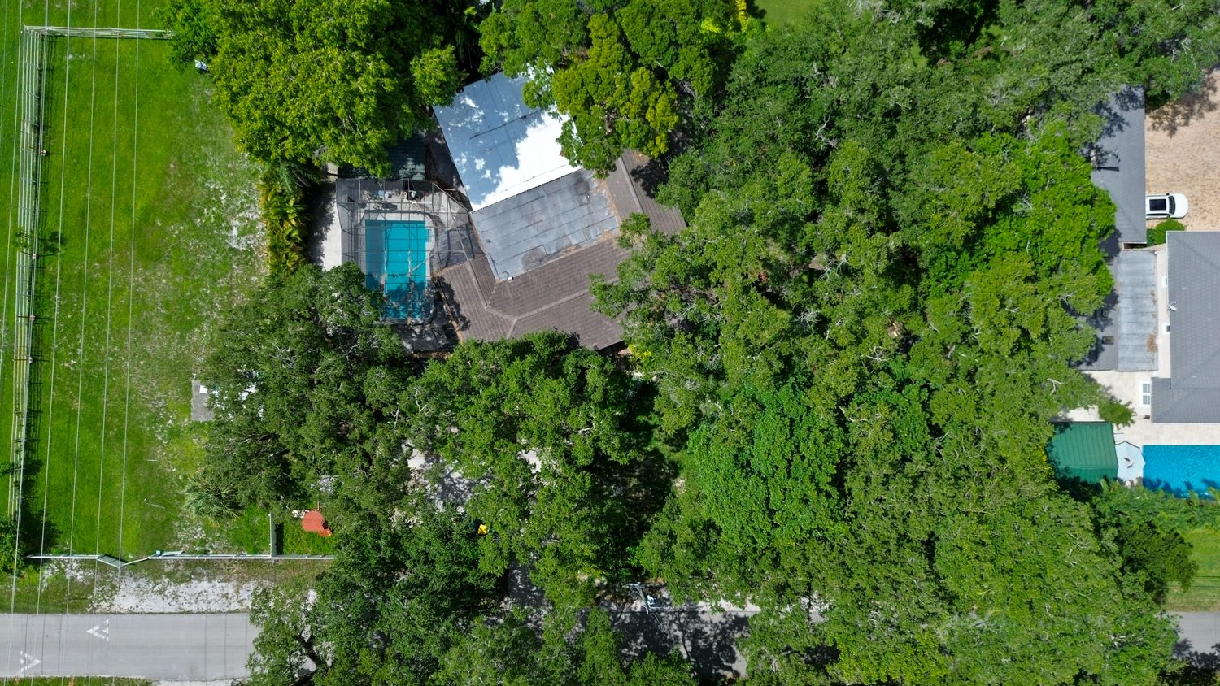
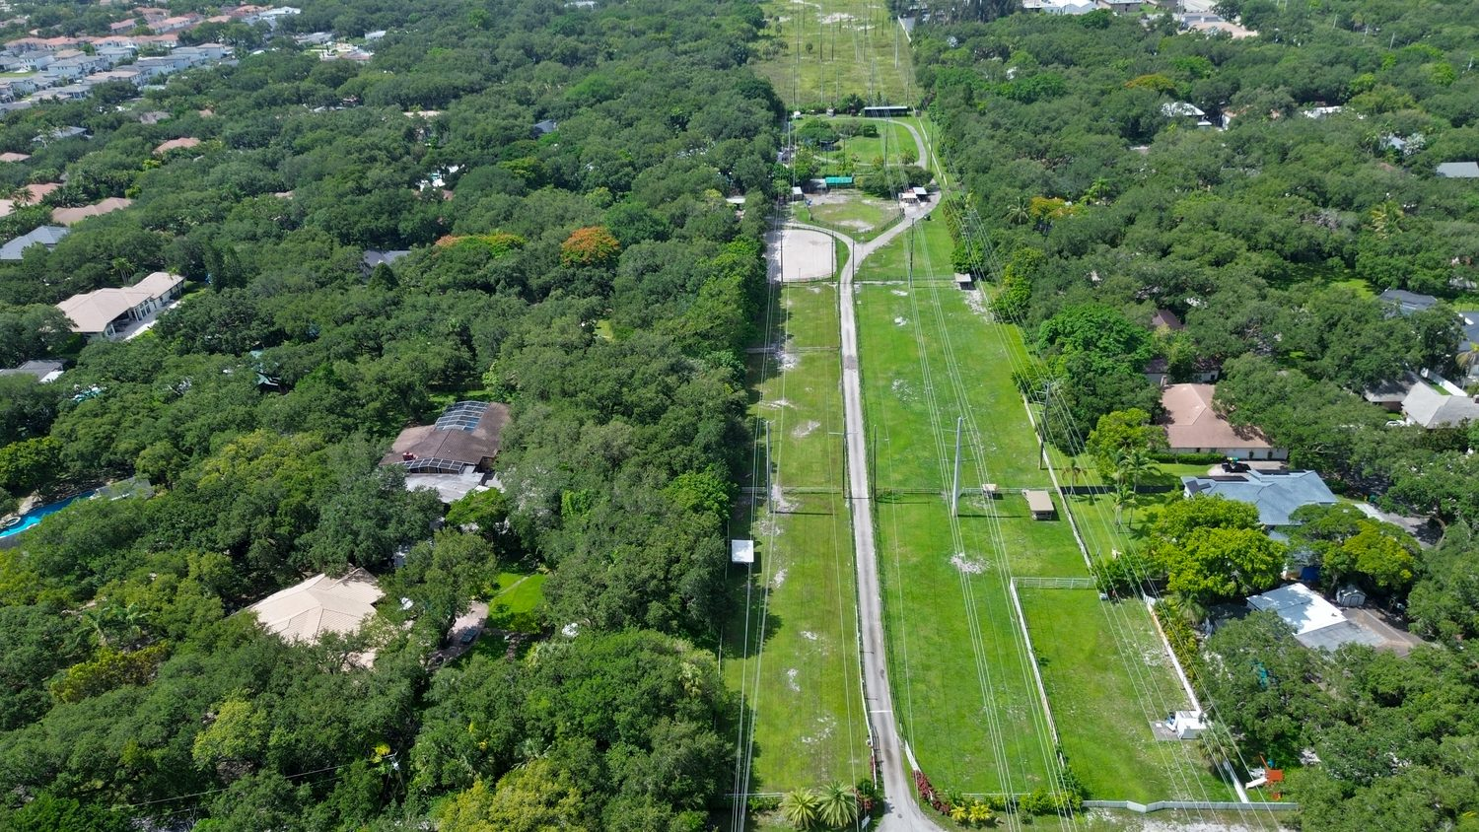
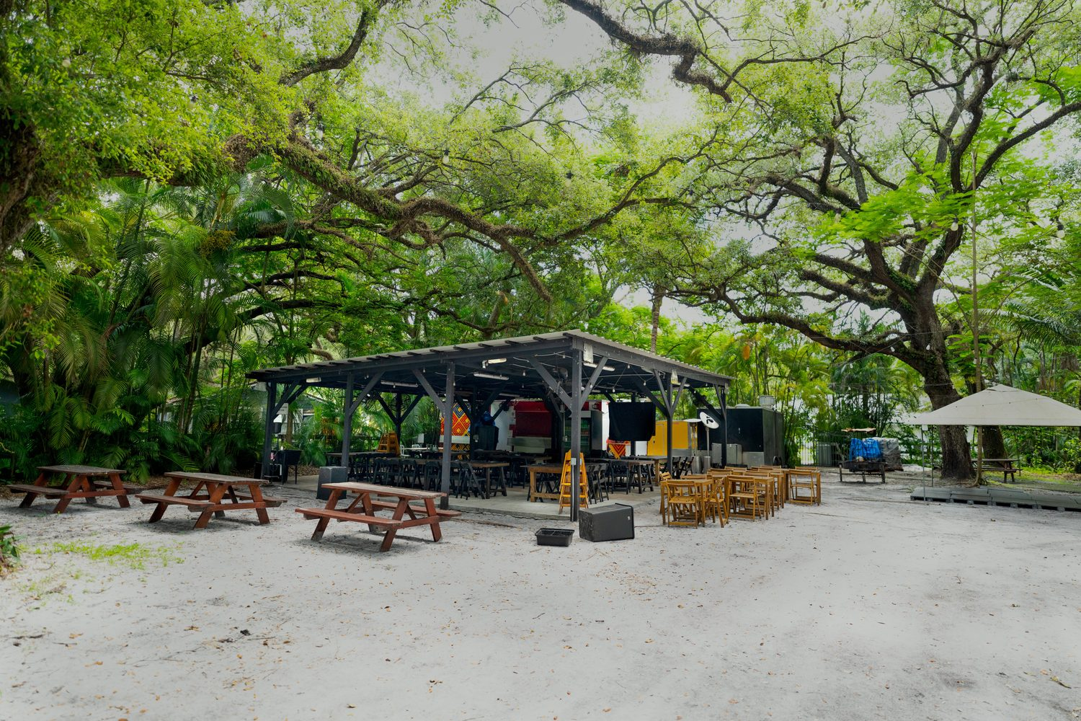

04 Investment Highlights

Rare Large-Scale Assemblage
Opportunities to acquire approximately 10 acres of contiguous land within Central Broward County are exceptionally limited, making this an unusually scarce land position.
Existing Cash Flow
In-place multifamily improvements generate income today, allowing an owner to carry the asset while planning, entitling, and executing a longer-term redevelopment strategy.
Strategic Location
The Property sits within one of Broward County’s fastest-growing redevelopment corridors, surrounded by major employment, entertainment, and transportation drivers.
Adjacent Redevelopment Precedent
The immediately adjacent Koosh Living project demonstrates the City’s willingness to support significant density increases on formerly estate-zoned land — a powerful proof point for this site.
Future Density Upside
Subject to municipal approvals, the assemblage offers the potential to substantially increase residential density through rezoning and entitlement, mirroring the adjacent precedent.
Institutional-Quality Opportunity
Scale, location, and entitlement upside combine to position the assemblage as a development opportunity suited to institutional and merchant-builder capital.

05 Adjacent Redevelopment Precedent

Koosh Living at Stirling — Approved Mixed-Use Development
The approval of Koosh Living, located immediately adjacent to the Lchaim Farm Assemblage, establishes a compelling redevelopment precedent. Its transformation from low-density estate zoning into a large-scale, six-story mixed-use community illustrates the significant long-term potential of the surrounding corridor.
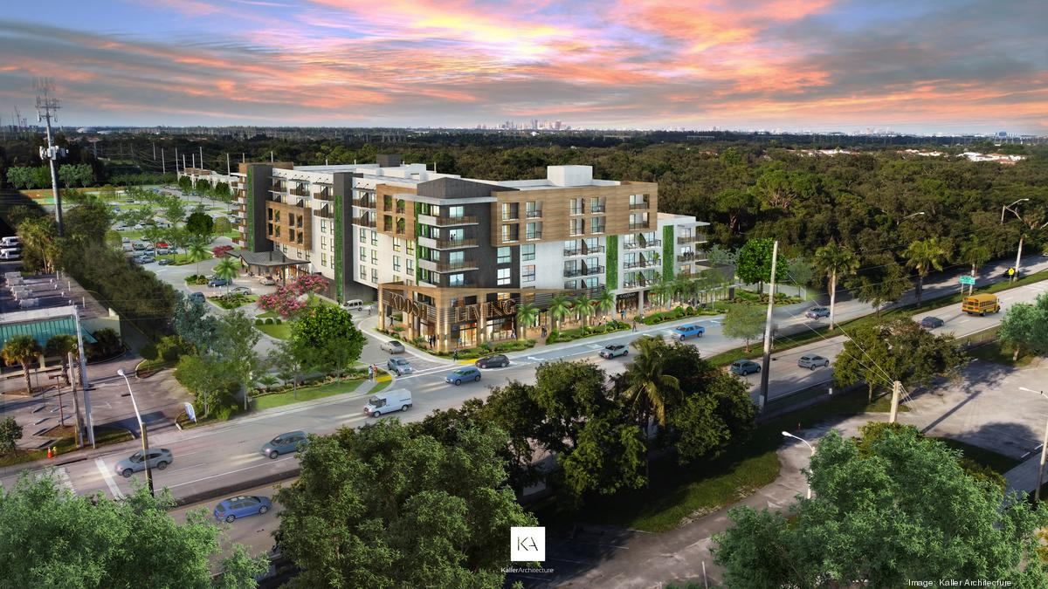
Koosh Living — approved mixed-use development immediately adjacent to the subject property. Rendering: Kaller Architecture.

Project | Koosh Living at Stirling
Address | 3725 Stirling Road, Dania Beach, Florida
Originally Zoned | E-1 Estate Residential
Approved Building Height | Six-story buildings
Luxury Apartments | 199 units
Townhomes | 32 units
Total Residential | 231 units
Commercial Components | Retail and office space
Community Components | Synagogue

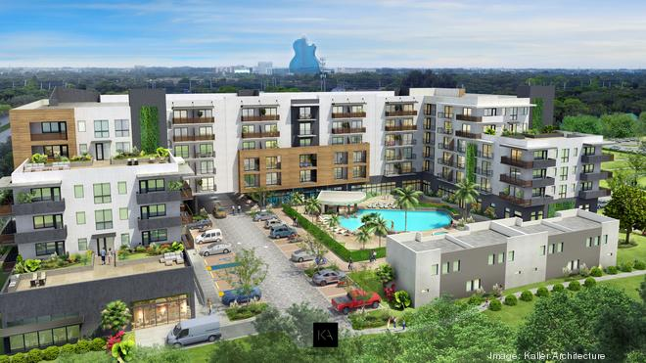
Koosh Living courtyard, pool, and townhomes, with the Seminole Hard Rock visible beyond. Rendering: Kaller Architecture.

Why it matters: An approval directly next door — taking a site from estate-residential zoning to 231 units across six-story buildings — provides tangible evidence of the density and mixed-use outcomes the City has been willing to entitle in this corridor.
Koosh Living figures are based on the approved development as represented and are provided for comparative reference only. Renderings courtesy of Kaller Architecture and are shown to illustrate the adjacent approved project; confirm reuse rights before distributing this Memorandum.

06 Location & Demand Drivers

The Lchaim Farm Assemblage is encircled by some of South Florida’s most significant employment, travel, and entertainment destinations — each a meaningful driver of rental housing demand.
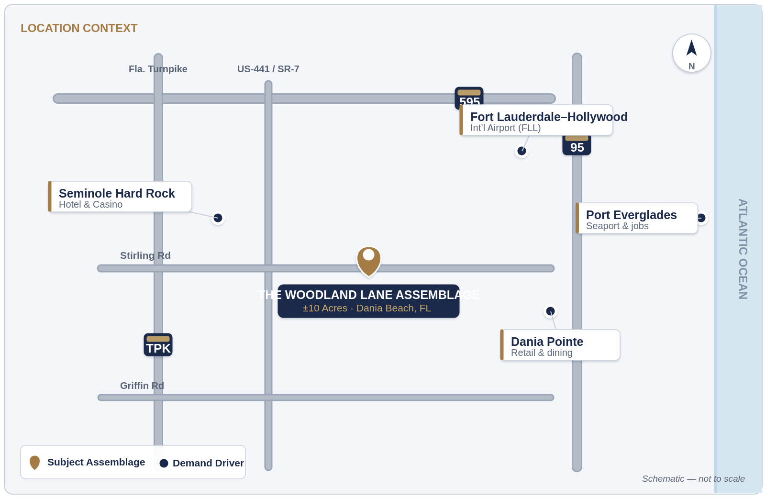
Location context — major demand drivers relative to the subject property (schematic; not to scale).
Seminole Hard Rock Hotel & Casino
One of South Florida’s largest employment and entertainment destinations, drawing both workers and visitors year-round.
Fort Lauderdale–Hollywood International Airport
A major regional gateway serving over 35 million annual passengers and a substantial source of area employment.
Dania Pointe
A premier open-air retail, dining, and entertainment destination anchoring the local lifestyle offering.
Port Everglades
A major employment center and economic engine for Broward County and the broader region.

Neighborhood Amenities
Beyond the region's major destinations, the Property is also convenient to everyday retail, dining, and schools serving the immediate community.
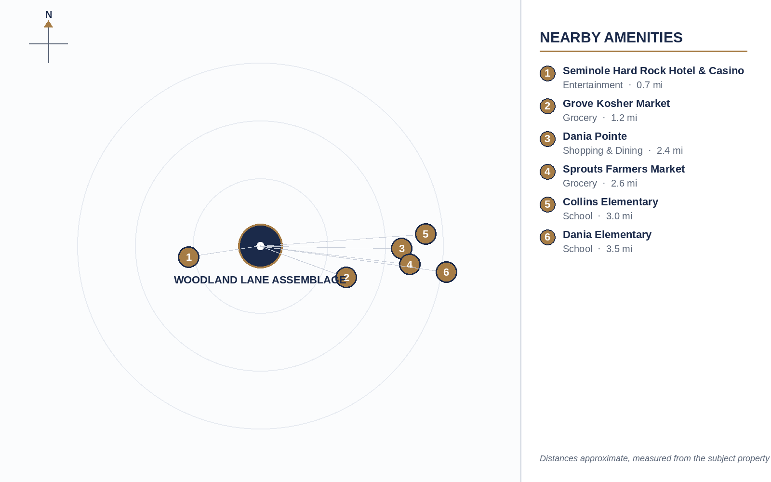
Nearby grocery, dining, school, and entertainment amenities relative to the subject property (schematic; not to scale).

Connectivity
Regional access is a defining strength of the location, with easy connections to I-95, I-595, Florida’s Turnpike, and US-441, plus proximity to the airport and the region’s major employment nodes.

07 Development Opportunity

Current Zoning
The Property is currently zoned E-1 Estate Residential.

Future Potential
The adjacent Koosh Living approval demonstrates the possibility of substantially increased residential density through rezoning and development approvals. Building on that precedent, a future owner may pursue a range of redevelopment concepts, all subject to governmental approvals.

Potential Future Concepts
Existing Farm
Continue the current agricultural and equestrian use, preserving in-place income and the existing character of the site.
Mega Compound
Consolidate the assemblage into a single large private estate or family compound.
School
Educational facility development, subject to municipal and governmental approvals.
Community Center
Civic or community-serving facility supporting the surrounding neighborhood.
Condo Buildings
Multi-story condominium development consistent with the adjacent density precedent.
Townhouses
For-sale or for-rent attached housing offering a transitional density profile.
Single-Family Homes
Traditional detached residential subdivision.

All development concepts described herein are conceptual and are expressly subject to municipal and governmental approvals that have not been obtained.

08 Market Fundamentals

Broward County continues to exhibit the supply-and-demand dynamics that underpin long-term value creation for well-located land and multifamily assets.
✓ Strong, sustained population growth across Broward County
✓ A continued structural housing shortage relative to demand
✓ Increasing rental demand from a growing resident base
✓ Limited infill development opportunities in established corridors
✓ Significant barriers to new land acquisition at scale

The scarcity of large, developable sites positions the Lchaim Farm Assemblage as a highly strategic acquisition opportunity within a supply-constrained market.

09 Financial Overview

The assemblage offers a dual return profile: in-place income from the existing multifamily improvements today, combined with redevelopment and density upside over the hold period. Detailed financials are available to qualified parties upon request and execution of a confidentiality agreement.

Offering Terms
Asking Price | Upon Request
Sale Structure | Fee-simple assemblage (all contiguous parcels)
Current Income | In-place multifamily rental income
Existing Units | Available upon request
Current NOI | Available upon request
Pricing Basis | Land value, in-place income, and density upside
Seller Financing | Available to qualified buyers — up to 80% of the purchase price (20% minimum down payment), term up to 5 years, 4% interest rate

EXCLUSIVELY OFFERED BY
Michael Benmeleh
Licensed Real Estate Broker
Beach City Realty
License #3123199
Phone 305-978-5988
Web showmemyami.com

This Offering Memorandum is confidential and intended solely for the recipient.

